

APPLICATION / PROGRAM REQUEST FORM
AI Dashboard & Automation Platform
Thank you for your participation in developing our AI Dashboard and Automation Platform. This form is designed to help the IT Team better understand your needs and implement the right solutions.
Please complete this form in as much detail as possible. The information you provide will greatly help us in designing and implementing solutions that meet your team's needs.

1. REQUESTOR INFORMATION
Requestor Name | Ari Eko Susilo
Team / Department | HRGA
Position / Title | HRGA Supervisor
Email | ari@ckd-otto.com
Phone / Extension | 204
Submission Date | 26-02-2026

2. REQUEST INFORMATION
Request Title | HRGA To Do List
Request Type | ☐ New Application  ☐ Automation Program/Script  ☐ Dashboard/Report  ☐ System Integration  ☐ AI Feature/Automation  ☐ Other: _________________
Priority | ☐ Urgent (< 1 month)  ☐ High (1-3 months)  ☐ Medium (3-6 months)  ☐ Low (> 6 months)

3. BACKGROUND AND OBJECTIVES

3.1 Problem Description / Business Need
Describe the problem or need driving this request. What is currently not working optimally or what do you want to achieve?
The highly complex nature of HRGA tasks requires teams to ensure they don't miss any tasks with specific deadlines. Therefore, the HRGA To-Do List allows you to monitor progress and deadlines in real time. Furthermore, the HRGA To-Do List is integrated into the HRGA e-Calendar.

3.2 Objectives and Benefits
What objectives do you want to achieve with this application/program? What benefits are expected for the Team?
1. Create a Single Source of Truth. All event schedules, strategic project progress, and vendor invoice statuses are now on one screen. This saves you time searching for documents or repeating inquiries with team members.

2. Mitigate Risk & Avoid Vendor Penalties. Build a good reputation and relationships with vendors, which can be beneficial when you need to negotiate prices.

3. Reduce Mental Load. By moving all schedules into an automated system, you free up your brain to focus on more important things: designing strategies, solving problems, and developing people, instead of just remembering when to pay bills.

4. Reporting to Management Becomes Very Fast, thanks to the reminder feature to complete work immediately.

5. Transparent Team Accountability: Higher levels can view/check their subordinates' to-do lists.

3.3 Current Process (As-Is State)
How is the process currently running? Describe the workflow, tools, or methods being used.
- HRGA Team input to do list separately by their self device
- HRGA Team monitoring manually to do list by excel file, notebook, or sticky notes
- HRGA Team should open calendar of event periodically, there is no automatically reminder by system

4. DETAILED SPECIFICATIONS

4.1 Main Functions / Features
List the main functions or features needed. Provide details for each feature.
- Feature 1: HRGA To Do List (Mgr, Spv, Officer)
- Feature 2: HRGA e Calendar (HRGA To Do List also integrated to HRGA e Calendar)
- Feature 3: HRGA TOP vendor alert/ the system will remind you if the remaining 7 days due date has not been processed)

4.2 Input Data
What data will be the input? What are the data sources? Data format (Excel, CSV, Database, Manual Input, etc.)?
Manual input

4.3 Expected Output / Results
What output is expected? (Report, Dashboard, File Export, Notification, Automated Action, etc.). Describe the format and content of the output.
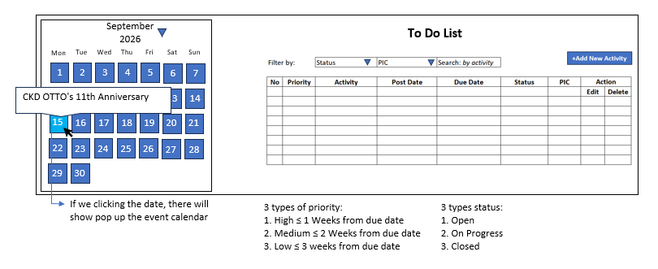
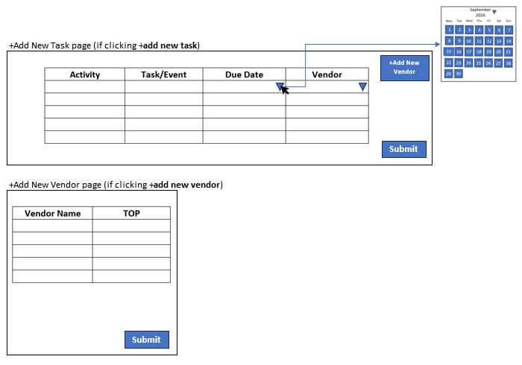

4.4 Desired Process / Workflow
Describe step-by-step how the application/program should work. Illustrate the process flow from input to output.
- Click +add new activity
- Complete the form
- Submit

4.5 Parameters / Configuration
Are there any specific parameters, filters, or configurations needed? (e.g., time period, product category etc.)
None

5. SYSTEM INTEGRATION

5.1 Related Systems / Applications
Does this application/program need to integrate with existing systems? Specify system names and types of integration.
None

5.2 Data to be Shared Between Systems
What data needs to be shared or synchronized with other systems?
None

6. USER AND ACCESS MANAGEMENT
Number of Users | 3
User Roles / Levels | Manager, Supervisor, Officer
Access Rights | Read, update

7. AI & AUTOMATION FEATURES (If Applicable)

7.1 Desired Automation
What processes do you want to automate? Automation frequency (real-time, daily, weekly, monthly)?
None

7.2 Required AI Features
Do you need AI for: prediction, classification, recommendation, analysis or others?
None

7.3 Automation Triggers / Conditions
What triggers the automation? (event-based, time-based, condition-based, etc.)
None

8. SECURITY & COMPLIANCE

8.1 Data Sensitivity
Will this application handle sensitive or confidential data? If yes, specify the types of data.
☐ Personal Data (PII)
☐ Financial Data
☐ Product Formula Data

☐ Company Confidential Data
☐ Other: _________________

9. ADDITIONAL INFORMATION

9.1 References / Examples
Are there any reference applications that can be used as examples? (screenshots, links, or descriptions)
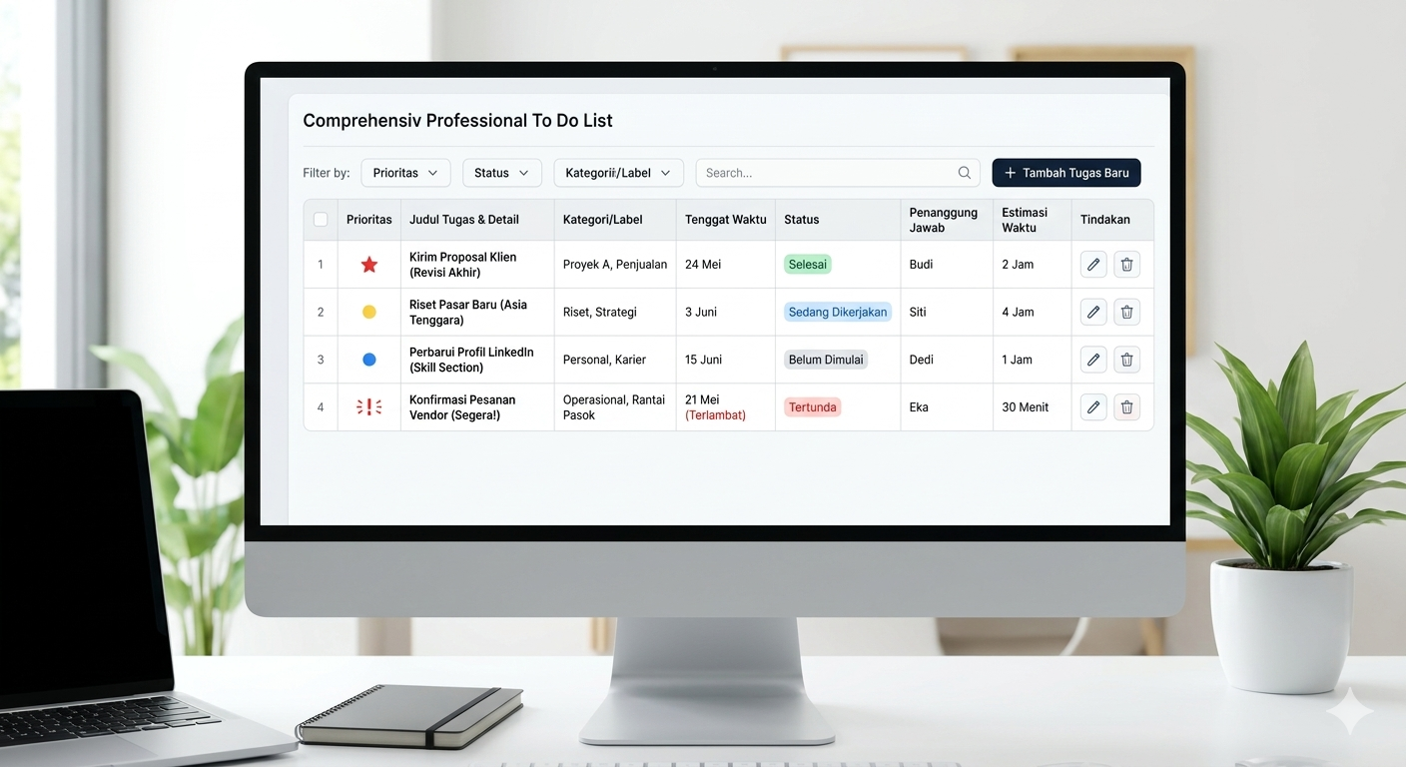

9.2 Attachments
Attach supporting files if available (sample data, mockups, flow diagrams, screenshots, etc.)
Attached files:

APPROVAL
Submitted By | Approved By (Team Head)
Name: Ari Eko Susilo  Date: April 13th, 2026 | Name: Ellvin  Date: April 13th, 2026

After completing this form, please send it to the IT Team via email or ticketing system.
The IT Team will review and contact you for further discussion.

